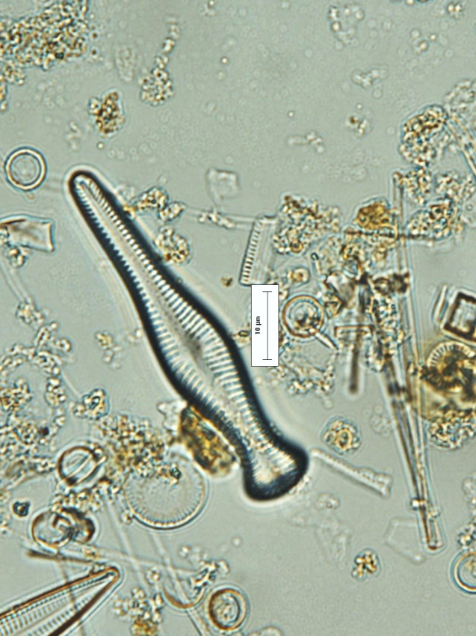
Gonphomema acuminatum
Figura 5: Fotomicrografia de Gomphonema acuminatum (escala 10μm) Figure 5: Photomicrograph of Gomphonema acuminatum (scale 10μm)

