Alessandra Cassoni
Universidade Guarulhos
Pós-Graduação em Odontologia
Praça Teresa Cristina, 229
Centro - Guarulhos - SP, Brazil
CEP 07023-070
Phone-Fax:55-11-2464-1758
acassoni@prof.ung.br or alcassoni@gmail.com

August 19th, 2009.

The Editor
Revista da Saúde

We are sending you the original manuscript entitled “Dental bleaching: case reports that achieved aesthetics results in dentistry with at-home bleaching systems” to be examined by the scientific referees’ appraisal. We would like to certify that manuscript was exclusively submitted to Revista da Saúde and that it is not concurrently under consideration for publication in another journal. All the named authors involved in the paper had read it before its submission to publication and confirmed the approval of the complete content.
ALESSANDRA CASSONI, DDS, MS, Ph.D
Guarulhos University, São Paulo, Brazil
Department of Restorative Dentistry, School of Dentistry
EDUARDO dos SANTOS LEONETTI, DDS
Guarulhos University, São Paulo, Brazil
ERIKA REIS TOYOSHIMA, DDS, MS
Guarulhos University, São Paulo, Brazil

Dr. Cassoni is assistant professor of Dental Research and Graduate Studies Division, Department of Restorative Dentistry, School of Dentistry, Guarulhos University
Dr. Leonetti is student of the Post-Graduate Program of Restorative Dentistry, School of Dentistry, Guarulhos University
Dr. Toyoshima has a master degree of the Post-Graduate Program of Restorative Dentistry, School of Dentistry, Guarulhos University

Alessandra Cassoni
Universidade Guarulhos
Pós-Graduação em Odontologia
Praça Teresa Cristina, 229
Centro - Guarulhos - SP, Brazil
CEP 07023-070
Phone-Fax:55-11-2464-1758
acassoni@prof.ung.br
Thank you in advance for your kind attention.
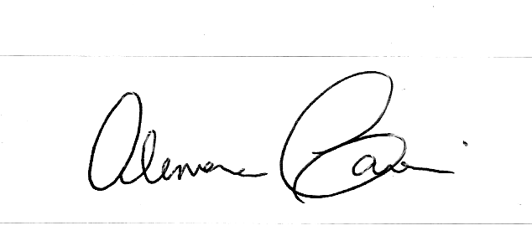
Sincerely yours,

Alessandra Cassoni

